

**Undergraduate Final Year Project**

**Requirements Analysis and Specification**

**Project Title** LOAD SHEDDING NOTIFICATION SYSTEM FOR ELECTRICITY SUPPLY COOPERATION OF MALAWI

**NAME**: JONATHAN MBENDERA

**Program Title**: Bachelor of Science (Hons) in Information Technology

**Project Supervisor:** Mrs. FUNSANI

Contents

Introduction 3

ORGANISATIONAL BACKGROUND 4

CURRENT SYSTEM 5

Non-Functional Requirements 10

Proposed solutions 11

Current system use case 14

Use case for the proposed system 16

References 19

# Introduction

The main goal of this document is to find out more about the user requirements and the functionalities of the new system. This document highlights the risk of the proposed system and the roles of the target users of the system in detail. The document also covers the current system description as well as the problems of the current load shedding system at Electricity Supply Cooperation of Malawi (ESCOM). The proposed system has been further analyzed using the Unified Modelling Language (UML) diagrams for example the class diagram and the use case diagrams.

## ORGANISATIONAL BACKGROUND

The Electricity Supply Corporation of Malawi (ESCOM) is a limited liability company established under the companies Act of 1984, ESCOM is the state-owned power producing company in Malawi. It is entirely in control of transmission and distribution of electric power in the country. ESCOM has estimated one million customers throughout the country, the company is divided into three sub companies namely, southern Electricity supply (SES), Central Electricity supply (CES) and Northern Electricity Supply (NES) runs distribution at region level.

## CURRENT SYSTEM

The country is experiencing frequent load shedding due to shortage of electricity for distribution to customers. In order to ensure equitable distribution of power to all customers, Electricity supply cooperation of Malawi (ESCOM) introduced a load shedding program model.

ESCOM advertises the load-shedding program through mass media to target their various customers, schedules are advertised on various media platforms in the country like newspapers, television stations, radio station and also via social media etc. Facebook.

The load shedding program consist of a weekly schedule for various locations across the county. In the current system a day has been divided into 3 equal segments of 8 hours each. Consequently, ESCOM’s domestic customers have also been divided into 3 groups A, B & C. A day starts from 4.00 am, the first day and ends at 4.00 am the next day.

On the first day of the program, the firs group, (A), has electricity supply for 8 hours from 4.00 am to 12.00 noon. The second group, (B) has electricity for 8 hours from 12.00 noon to 8.00 pm; and the last group, (C) has electricity supply for 8 hours from 8.00 pm to 4.00 am. The first day of the program is finished.

The load shedding periods are rotated. As such, on the second day of the program, group (C), (which was the last to have power supply on the first day) is the first to have power supply for 8 hours from 4am to 12 noon, Group (A) is second to be supplied power for 8 hours from 12.00 noon to 8.00 pm; group (B) is the last to be supplied power for 8 hours from 8.00 pm to 4.00 am. The second day is finished.

However, because Group (C) was the last to have power on the first day and the first to have power on the second day, Group C has power for a continual period of 16 hours; from 8pm on the first day to 12 noon on the second day. This is so as its 8 hours of power supply of the first day (from 4am to 12 noon), making it a total of 16 hours. This shall be the same case for any group that is supplied power last on any particular given day. On the following day, it shall be the first to be supplied power. As such, it shall have a continual supply of power for 16 hours.

Due to the rotation, group (A), which was the first to be supplied power on the first day (from 4 am to 12 noon), is the second to be supplied power on the second day (from 12 noon to 8 pm). As its load shedding started at 12 noon on the first day, it ends at 12 noon on the second day, making it a total of 24 hours of load shedding for group A. similarly, group (B) which was second to be supplied power on the first day (from 12 noon to 8 pm) is the third to supplied power on the second day (8 pm to 4 am). As its load shedding started at 8 pm on the first day, it also ends at 8 pm on the second day, making it a total of 24 hours of load shedding for group B.

However, Group C which was the last to be supplied power on the first day (from 8pm to 4am) and the first to be supplied power on the second day (from 4am to 12noon) will be load shed from 12 noon on the second day to 12 noon on the third day. This is so since it was the first to be supplied power on the second, and the will be the second to be supplied power on the third day. This cycle continues for the rest of the week.

Flows of the current system

This section addresses problems faced within Electricity Supply Cooperation of Malawi’s current system. The current system is a combination of spreadsheet and paper-based approach. The following are the problems regarding the current system.

* Consumers tend to miss out on the load-shedding program since for one to access the schedules has to have access to these media platforms for example people may not know when the programs are being advertised like on radio stations etc.
* Information overload is one of the problems of the current system in a sense of a way that consumers find it difficult to track load shedding schedules of their respective areas/ locations, since there is too much information available at one place.
* The service provider (ESCOM) find the current system very expensive since it involves advertising to various medias which doesn’t come cheap.
* These load-shedding schedules are prone to changes at time which is difficult to notify customers when any changes occur
* No customer engagement in the current system since all customers do is to view the program
* The system is not efficient that customers struggle to access the load-shedding schedules

**REQUIREMENTS GATHERING METHODS**

In this section we will discuss some of the requirements gathering methods which aided the project analysis.

Interviews

Interviews where conducted to the consumers/ customers and some of the organization’s employees which helped in understanding their goals and expectations and how they can be satisfied.

DECISIONS MADE BASED ON INTERVIEWS

Upon conducting interviews with the users of the current system it was observed that the system has flaws that customers fail to understand and keep track of load-shedding schedules.

On the other hand, it was also observed that clients have problems tracking load-shedding schedules and require a mobile platform from which they can easily access schedules and receive notifications whenever necessary.

Based on the findings from the interviews conducted with system users, it was established that an automated system be implemented as an ideal solution to curb the problems in the current system.

**Functional Requirements**

This process generalizes the requirements that the system intends to achieve. They can also be known as the characters of the intended system. They are two types which is the functional and the Non-Functional requirements. The new system to be developed should be able to do the following processes

**Must have**

**Post schedules**

this functional requirement supports posting of load shedding programs by the administrator

**search location**

this functional requirement supports searching schedules for a particular location

**post notification**

sending notifications or updating user whenever these schedules change

**view schedules**

user to be able to view schedules which is the main reason of the system

**Modify load-shedding schedules**

To enable the system administrator to make changes on the schedules like editing, deleting, and updating.

**Should have**

**Push notification**

Users to get notifications on when load shedding will take place and when load shedding stage changes

**Download schedules**

Users to download or save load-shedding schedules for offline use or to share with others

**Create profile**

Users to be able to create profile to save their favorite locations

**Could have**

**submit complaint**

This functional requirement supports users to report outages and errors in load shedding schedules

**Set alarm**

Set notification times and intervals

**Won’t have**

**Creation of user account**

This function requires users to create an account

# Non-Functional Requirements

1. Speed

This system will provide a high speed in loading time and every activity which users will access. This is to ensure that a lot of time is not wasted for the users to gain access to the information.

1. User Interactive.

The system will have a user-friendly interface by providing a Graphical User Interface, easy to use help facility and a map key.

1. Data Validity

The system will provide data checks which will validate the input data according to defined standard.

1. Data security

The system will ensure that the private details of the customers are kept secure and are not accessed by any third party.

1. Flexibility

The system will be flexible in the sense of a way that it can be able to adapt to changes

# Proposed solutions

Research that was carried out determined Propose solutions to the problems faced by the current system. Whilst maintaining focus on the business need, 3 solutions were proposed which have been discussed n this section with the aim of achieving the business case and business goal of the organization. The following are the proposed solutions.

1. **Mobile based application**

The type of application software designed to run on a mobile device, such as Smartphone or tablet computer, they serve a purpose same as some desktop applications. Mobile applications are further categorized into two types mainly

* **Native apps**

These are mobile apps mainly built for a particular platform (operating system) like Android, IOS, Windows Phone and Blackberry, they can’t be used interchangeably between platforms. In other words, an Android app can’t, be used on iPhone.

Its main advantage is that they offer best performance since the app is created and optimized for a specific platform.

While its drawback is that it has higher cost of development and maintenance due to the need of creating app duplicates for other platforms.

* **Hybrid apps**

These are mobile apps built using multi-platform web technologies that it has cross-platform compatibility that it works on all platforms be it IOS, Android etc.

Its advantage it’s that they are fast and relatively easy to develop, once its developed can work on all platforms using a single code base therefore ensuring low-maintenance cost and smooth updates.

The disadvantage being that hybrid applications has performance issues like speed and overall optimization in comparison to other types of mobile apps.

1. **Web-based application**

These are applications that are accessed over a network connection using HTTP, they often run inside a web browser. It is stored on a remote server and delivered over the internet through a browser interface. Below are the advantages and disadvantages of web-based application

**Advantages**

* They are accessible anywhere, anytime using any device with internet connection. This allows the user to be in charge of where and when they can access the application
* Easy to maintain and install, for instance when a new version or upgrade is ready can only be installed on the host server and users can access the changes on their various devices without doing the initial upgrade on their machines.

**Disadvantages**

* Reliance on internet, that they can’t be used offline, once you lose connection the web can’t be accessed.
* Browser compatibility, in other cases web applications struggle to fit in other browsers making it difficult for users to access the web.
* Security is also a downside since all data is stored in a central location that any breach of security will mean that all data is compromised.

1. **Stand-alone application**

it is a type of software application that is not bundled with any type of software, in other words the software application does not depend on other software applications for its existence. On the other hand, this type of application software can create problems if need of integration with other applications arises since it was built for independent purposes.

**Chosen solution and justification**

A proper research was done and a decision was made in favor of both the organization and the consumer who are the beneficiary of the proposed system. We concluded that a hybrid mobile application is the best for the development of the system, which is a mobile load shedding system for Electricity supply cooperation of Malawi (ESCOM). This decision has been justified below

Nowadays people rely on their mobile devices for just about any activity imaginable and any company that is not a part of this global trend seems to be out of reach. Below are the benefits of hybrid application software to be developed for the organization

1. **Offline support**

* Hybrid apps offers offline support, so this is a bonus to users since Malawi is a developing country, people do face difficulties accessing internet due to high internet tariffs, the application will offer offline support whereby users can access the application offline

1. **Unified development**

* The company will save a substantial amount of money since a single application will be developed for all platforms rather spent more on developing and maintaining separate code bases for different mobile platforms.

1. **High-end user experience**

* Hybrid apps offers built in UI components which is suitable for the project requirements therefor reduces overall development effort. User experience is extensively improved with the UI elements.

1. **Supports multi-platform**

* This type of mobile application supports all platforms

1. **Easy to maintain**

* These apps are flexible that it makes them easy to maintain

# Current system use case

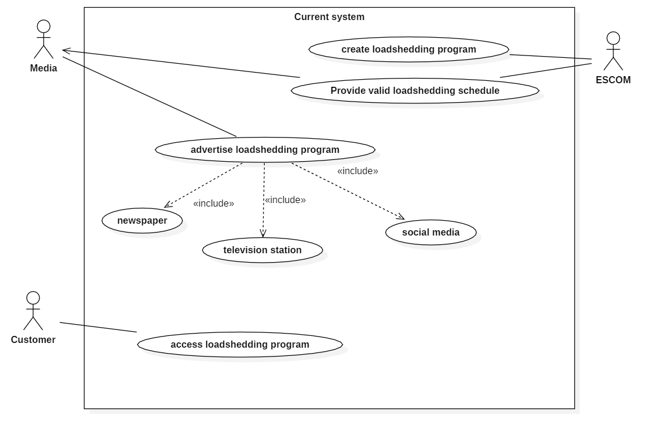

**CURRENT SYSTEM USE CASE DESCRIPTION**

The table below provides a description of the use cases and the activities the actors are performing.

|  |  |  |
| --- | --- | --- |
| ACTOR | USE CASE | DESCRIPTION |
| ESCOM | Create load-shedding program | Company creates the schedules of load-shedding |
|  | Provide valid schedules | Verified final schedules are produced ready for use |
| Media | Advertise the schedules/ post | Schedules posted on different media platforms |
| customer | Access/ view load-shedding program | Access load-shedding scheduled on media platforms |

# Use case for the proposed system

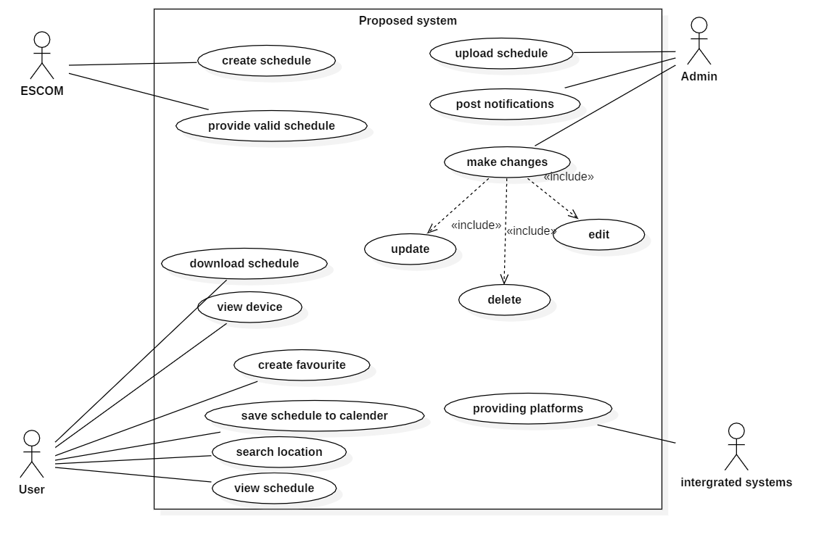

Description

|  |  |  |
| --- | --- | --- |
| ACTOR | USE CASE | DESCRIPTION |
| ESCOM | Create load-shedding program | Company creates the schedules of load-shedding |
|  | Provide valid schedules | Verified final schedules are produced ready for use |
| Admin | Upload schedule | Upload schedules on the system |
|  | Post notifications | Posting notifications on any changes on the load-shedding schedules |
|  | Make changes | Making changes in the form of deleting, updating and editing the schedules |
| User | View device | Accessing the application |
|  | Search location | Entering and searching for a particular location |
|  | Download schedule | Downloading the load-shedding program |
|  | Set favorites | Creating a profile to save favorite locations |
|  | View schedule | Viewing load-shedding program |
| Integrated systems | Providing platform | Providing platforms to user like contacting the company (ESCOM) via Facebook or users lodging complaints |

Initial class diagram

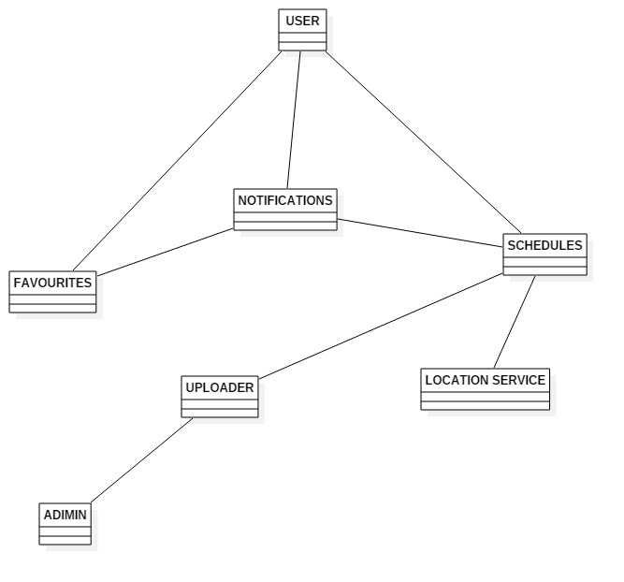

(Canavesi, 2016)

Canavesi, B., 2016. *brookscanavesi.* [Online]   
Available at: rookscanavesi.com/uncategorized/benefits-disadvantages-hybrid-mobile-applicationsb/  
[Accessed 7 january 2019].

(corporate, 2017)

# References

Canavesi, B., 2016. *brookscanavesi.* [Online]   
Available at: rookscanavesi.com/uncategorized/benefits-disadvantages-hybrid-mobile-applicationsb/  
[Accessed 7 january 2019].

corporate, T.-., 2017. *Tvisha.* [Online]   
Available at: http://www.tvisha.com/blog/benefits-of-hybrid-apps/  
[Accessed 22 january 2019].